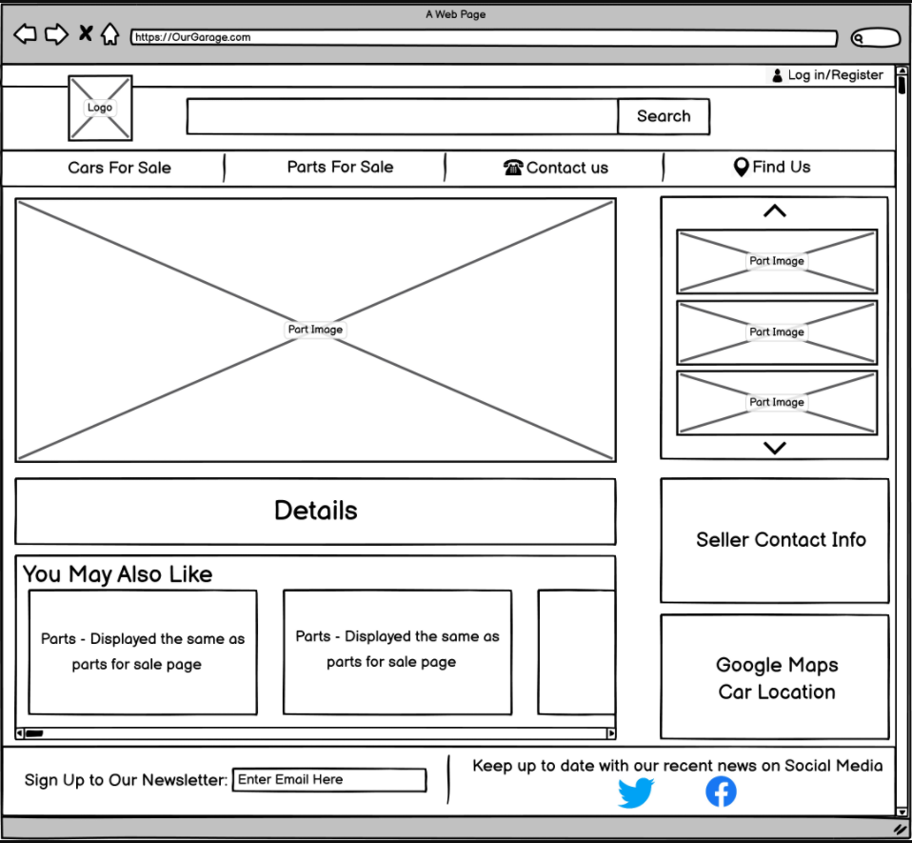

3

15

14

13

12

11

10

9

8

7

6

5

4

2

1

|  |
| --- |
| 1. Company logo, will be used as a return to Home Page Button, see logo for visual |
| 1. Search box to search for a specific Part or car |
| 1. Log in/ sign up button depending on if you are logged in or not |
| 1. Cars for sale button, to redirect to the car for sale page |
| 1. Parts for sale button, to redirect to the parts for sale page |
| 1. Contact us button, to redirect to the page with contact information |
| 1. Find Us button, to redirect to the page with a map |
| 1. Image of the part chosen to get more details of |
| 1. Different angles of the part |
| 1. Details of the part including price, name etc |
| 1. More parts relating to this part |
| 1. Contact information of the seller (garage or 3rd party through garage) |
| 1. Location of the part/seller |
| 1. Newsletter, an option for people to enter their emails to receive a newsletter |
| 1. Links to social media page |

|  |
| --- |
| 1. Logo, Blue with yellow car outline and white text |
| 1. White text box with blue button |
| 1. White text box with blue button |
| 1. White button with blue text |
| 1. White button with blue text |
| 1. White button with blue text |
| 1. White button with blue text with phone icon |
| 1. Image of Part, if not filled the area then on white background |
| 1. Smaller pictures of the part |
| 1. Bullet list, black text |
| 1. Displays first image of other parts |
| 1. White with blue/dark blue text and outlining |
| 1. White with blue/dark blue text and outlining |
| 1. Dark Blue |